Intro Leadership 9/10
Conflict Resolution with Self and Others: Assignment Three
/20
Preamble
You have learned about types of conflict, techniques for conflict resolution, and you have been given some time to think about what ‘default’ responses you have typically had in the past. Now it’s time to think about the part you play in conflict, and think about ways to lessen potential conflict in your life.
Assignment
You will have 30 minutes to complete this assignment so use your time wisely. Listen to the video below, read the information attached, and answer the following questions, meant to ‘poke’ your thinking a bit. As always, no one will see your responses, except you and me, unless your health and safety are in question.
Assessment
You will be assessed, as per the usual, on depth of thought and accuracy.
The Four Agreements: A Practical Guide to Personal Freedom, a Toltec Wisdom Book, by Don Miguel Ruiz, highlights the idea that a lot of conflict in our life can be lessened if we follow some basic guidelines with ourselves and others. Whether it is true that this wisdom came from Mexico and the Toltecs one thousand years ago or not, the tenets still offer us some help in conflict resolution and more opportunity for peace.
- Watch the video below and write the important information about the Four Agreements in the space provided.
https://www.youtube.com/watch?v=yQWnAXEnSN0

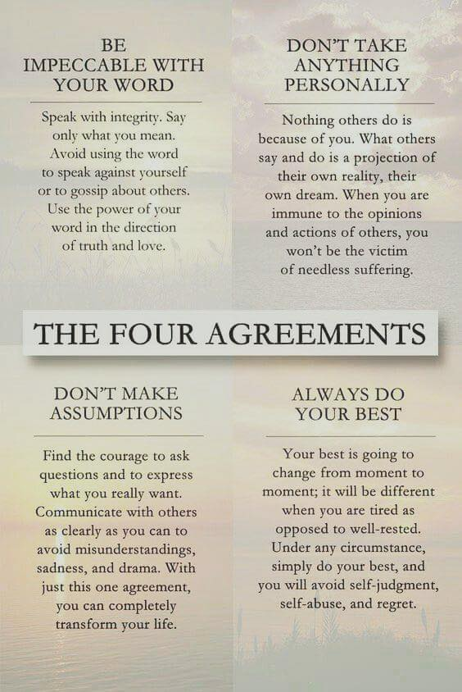

- Think about a recent conflict you’ve been in. Give only the details you want, but analyze how you followed the Four Agreements. Be honest…there is no point in doing this if you are not!
What happened?

Be impeccable with your word. Were you? | Don’t take anything personally. Did you?
Don’t Make Assumptions. Did you? | Always do your best. Have you been?

- Find a quote from the book that resonates with you and explain why it does. What is the significance of the quote?
“Action is about living fully. Inaction is the way that we deny life. Inaction is sitting in front of the television every day for years because you are afraid to be alive and to take the risk of expressing what you are. Expressing what you are is taking action.”

“Doing your best is taking the action because you love it, not because you’re expecting a reward. Most people do the exact opposite: They only take action when they expect a reward, and they don’t enjoy the action. And that’s the reason why they don’t do their best.”

“If I love myself I will express that love in my interactions with you, and then I am being impeccable with the word, because that action will produce a like reaction. If I love you, then you will love me. If I insult you, you will insult me. If I have gratitude for you, you will have gratitude for me. If I’m selfish with you, you will be selfish with me.”

“We don’t need to justify love; it is there or not there. Real love is accepting other people the way they are without trying to change them. If we try to change them, this means we don’t really like them.”

“Gossiping has become the main form of communication in human society. It has become the way we feel close to each other, because it makes us feel better to see someone else feel as badly as we do. There is an old expression that says, ‘Misery likes company,’ and people who are suffering in hell don’t want to be all alone.”

“Nothing other people do is because of you. It is because of themselves. All people live in their own dream, in their own mind; they are in a completely different world from the one we live in. When we take something personally, we make the assumption that they know what is in our world, and we try to impose our world on their world. Even when a situation seems so personal, even if others insult you directly, it has nothing to do with you. What they say, what they do, and the opinions they give are according to the agreements that they have in their own minds.”

“You can only be you when you do your best. When you don’t do your best you are denying yourself the right to be you. That’s a seed that you should really nurture in your mind. You don’t need knowledge or great philosophical concepts. You don’t need the acceptance of others. You express your own divinity by being alive and by loving yourself and others.”

“We have the need to be accepted and to be loved by others, but we cannot accept and love ourselves. The more self-love we have, the less we will experience self-abuse. Self-abuse comes from self-rejection, and self-rejection comes from having an image of what it means to be perfect and never measuring up to that ideal. Our image of perfection is the reason we reject ourselves; it is why we don’t accept ourselves the way we are, and why we don’t accept others the way they are.”

“The world is very beautiful and very wonderful. Life can be very easy when love is your way of life. You can be loving all the time. This is your choice. You may not have a reason to love, but you can love because to love makes you so happy. Love in action only produces happiness. Love will give you inner peace. It will change your perception of everything.”

“When you feel good, everything around you is good, when everything around you is great, everything makes you happy. You are loving everything that is around you, because you are loving yourself. Because you like the way you are. Because you are happy with your life. You are happy with the movie that you are producing, happy with your agreements with life. You are at peace, and you are happy. You live in that state of bliss where everything is so wonderful, and everything is so beautiful.

Highlight the quote you are choosing to analyze, and write your response here.
_______________________________________________________________________________________________________________________________________________________________________________________________________________________________________________________________________________________________________________________________________________________________________________________________________________________________________________________________________________________________________________________________________________________________________________________________________________________________________________________________________________________________________________________________________________________________________________________________________________________________________________________________________________________________________________________________________________________________________________________________________________________________________________

