Core Competencies Workshop 2017
Mentors and Tutor Leaders
Agenda

8:45am Shape of the Day and Housekeeping
9:00am Icebreaker Activity (Mentors to run)
9:15am Overview of Core Competencies (ppt)
9:30am Activity One
10:00am Break
10:15am Activity Two
11:15 Debrief Activity One and Two
11:25am Questions/Issues/Concerns/Ah Ha Moments
11:30 Moving Forward and Closing

Expectations: To help your students, you need to learn about the competencies and think about how they would apply to your own learning. Once you can do that, you will be able to teach this to others!

Notes and Doodles

For more information, or to view the video and powerpoint, go to the following sites:

https://www.curriculum.gov.bc.ca/
https://www.cccnorth.weebly.com
Activity One: Choosing a Core Competency, Finding Evidence, and Using I Can Statements
Think about your own learning this year and answer the following in point form:
(Remember this learning can be from a class, across your classes (multidisciplinary), or in the school and larger community.
1. What learning/projects/growth/skills are you most proud of this year?

2. Was this from a class, across your classes (multidisciplinary), or in the school and larger community?

3. Which of the three core competencies match best with the learning?

4. How does this learning/project/growth/skill match with the core competency? (Support your answer with evidence)
Evidence One:

Evidence Two:

Evidence Three:
5. Write the core competency you chose on a stickie and put it up on the board in the appropriate spot.

Next, highlight all the “I CAN” statements that apply best to you.
I can statements for Students

COMMUNICATION:

Connect and engage with others (to share and develop ideas)
- · I ask and respond to simple, direct questions.
- · I am an active listener; I support and encourage the person speaking.
- · I recognize that there are different points-of-view and I can disagree respectfully.
- Acquire, interpret, and present information (includes inquiries)
- · I can understand and share information about a topic that is important to me.
- · I present information clearly and in an organized way.
- · I can present information and ideas to an audience I may not know

Collaborate to plan, carry out, and review constructions and activities
- · I can work with others to achieve a common goal; I do my share.
- · I can take on roles and responsibilities in a group.
- · I can summarize key ideas and identify the ways we agree (commonalities)

Explain/recount and reflect on experiences and accomplishments
- · I give, receive, and act on feedback.
- · I can recount simple experiences and activities and tell something I learned.
- · I can represent my learning, and tell how it connects to my experiences and efforts.

CREATIVE THINKING:

Novelty and value

- I get ideas when I play.
- · My ideas are fun for me and make me happy.
- · I can get new ideas or build on other people’s ideas, to create new things within the constraints of a form, a problem, or materials.
- · I generate new ideas as I pursue my interests.
- · I get ideas that are new to my peers. I can develop a body of creative work over time in an area I’m interested in or passionate about
Generating ideas
- · I get ideas when I use my senses to explore.
- · I build on others’ ideas and add new ideas of my own, or combine other people’s ideas in new ways to create new things or solve straightforward problems.
- · I deliberately learn a lot about something (e.g., by doing research, talking to others or practising) so that I am able to generate new ideas or ideas just pop into my head.
- · I have deliberate strategies for quieting my conscious mind (e.g., walking away for a while, doing something relaxing, being deliberately playful) so that I can be more creative.
- · I have interest and passions that I pursue over time.

Developing ideas
- · I make my ideas work or I change what I am doing.
- · I can usually make my ideas work within the constraints of a given form, problem, and materials if I keep playing with them.
- · I build the skills I need to make my ideas work, and usually succeed, even if it takes a few tries.
- · I use my experiences with various steps and attempts to direct my future work.
- · I can persevere over years if necessary to develop my ideas. I expect ambiguity, failure, and setbacks, and use them to advance my thinking.

CRITICAL THINKING

Analyze and critique
- · I can show if I like something or not. I can identify criteria that I can use to analyze evidence.
- · I can analyze evidence from different perspectives.
- · I can reflect on and evaluate my thinking, products, and actions.
- · I can analyze my own assumptions and beliefs and consider views that do not fit with them

Question and investigate
- · I can explore materials and actions.
- · I can ask open-ended questions and gather information.
- · I can consider more than one way to proceed in an investigation.
- · I can evaluate the credibility of sources of information.
- · I can tell the difference between facts and interpretations, opinions, or judgments.
Develop and design
- · I can experiment with different ways of doing things.
- · I can develop criteria for evaluating design options.
- · I can monitor my progress and adjust my actions to make sure I achieve what I want.
- · I can make choices that will help me create my intended impact on an audience or situation.
SOCIAL RESPONSIBILITY

Contributing to community and caring for the environment
- · With some support, I can be part of a group.
- · I can participate in classroom and group activities to improve the classroom, school, community, or natural world.
- · I contribute to group activities that make my classroom, school, community, or natural world a better place.
- · I can identify how my actions and actions of others affect my community and natural environment and can work to make positive change.
- · I can analyze complex social or environmental issues from multiple perspectives. I can take thoughtful actions to influence positive, sustainable change.

Solving problems in peaceful ways
- · I can solve some problems myself and can identify when to ask for help.
- · I can identify problems and compare potential problem-solving strategies.
- · I can clarify problems, consider alternatives, and evaluate strategies.
- · I can clarify problems or issues, generate multiple strategies, weigh consequences, compromise to meet the needs of others, and evaluate actions.
- · With some direction, I can demonstrate respectful and inclusive behaviour.
- · I can explain when something is unfair.
- · I can advocate for others.
- · I take action to support diversity and defend human rights, and can identify how diversity is beneficial for my Valuing Diverse community, including online.

Building relationships
- · With some support, I can be part of a group.
- · I am kind to others, can work or play co-operatively, and can build relationships with people of my choosing.
- · I can identify when others need support and provide it.
- · I am aware of how others may feel and take steps to help them feel included.
- · I build and sustain positive relationships with diverse people, including people from different generations.

POSITIVE PERSONAL & CULTURAL IDENTITY

Relationships and cultural contexts

- · I can describe my family and community.
- · I am able to identify the different groups that I belong to.
- · I understand that my identity is made up of many interconnected aspects (such as life experiences, family history, heritage, peer groups).
- · I understand that learning is continuous and my concept of self and identity will continue to evolve.
Personal values and choices

- · I can tell what is important to me.
- · I can explain what my values are and how they affect choices I make.
- · I can tell how some important aspects of my life have influenced my values.
- · I understand how my values shape my choices.

Personal strengths and abilities
- · I can identify my individual characteristics.
- · I can describe/express my attributes, characteristics, and skills.
- · I can reflect on my strengths and identify my potential as a leader in my community.
- · I will continue to develop new abilities and strengths to help me meet new challenges.

PERSONAL AWARENESS & RESPONSIBILITY
Self-determination
- · I can show a sense of accomplishment and joy.
- · I can celebrate my efforts and accomplishments.
- · I can advocate for myself and my ideas.
- · I can imagine and work toward change in myself and the world.
- · I take the initiative to inform myself about controversial issues.

Self-regulation
- · I can sometimes recognize emotions.
- · I can use strategies that help me manage my feelings and emotions.
- · I can persevere with challenging tasks.
- · I can implement, monitor, and adjust a plan and assess the results.
- · I can take ownership of my goals, learning, and behaviour.

Well-being

- · I can participate in activities that support my well-being, and tell/show how they help me.
- · I can take some responsibility for my physical and emotional well-being.
- · I can make choices that benefit my well-being and keep me safe in my community, including my online interactions.
· I can use strategies to find peace in stressful times. I can sustain a healthy and balanced lifestyle.
https://curriculum.gov.bc.ca/competencies
Now doublecheck the core competency that you chose at the beginning of Activity One. Is this the section most highlighted in the I Can Statements? If not, you may want to reassess which competency you choose for your interview!
Activity Two: How to Prepare for an Interview

Now that you have thought about which core competency you would like to highlight for you interview, and you have thought about some evidence to demonstrate your strengths, it is time to think about your interview.

Brainstorm

How can we prepare for an interview? What tips are important to go over with the grade 8/9 students? Brainstorm in the space below. (Think/pair/share)

Mock Interviews

1. Read the criteria format and questions below that will be utilized for May 17th, 2017, by teachers

2. Get into pairs or groups of three (please make sure no one is left by themselves). Create groups where you are not with your
friends so it resembles more what the actual interview will feel like for the grade 8/9 students.

3. Take turns in the role of interviewer, interviewee, and listener (for groups of three). Interviewers should use the questions
below to guide the conversation.

Unpacking the Preparation and the Interview:

What was it like to go through this process? What tips/ideas do you have to make this process easier for your students?

Core Competency Chats - May 17th 2017

Format:
A student led conversation or chat about their growth in one of the competencies. Students can choose to have a conversation individually, in pairs, or in groups of three. Content is not specific to one subject area but should be cross-curricular in nature and may include growth in extra-curricular areas.

The day will be an adjusted five-period day schedule with Competency Chats occurring during the first period. Grades 10-12 will have a soft start to the day. You will receive a list of 6 students that you will be chatting with, including their preferred chat format. At the end of the conversations, you will submit your list of completed/no shows to Dianne.
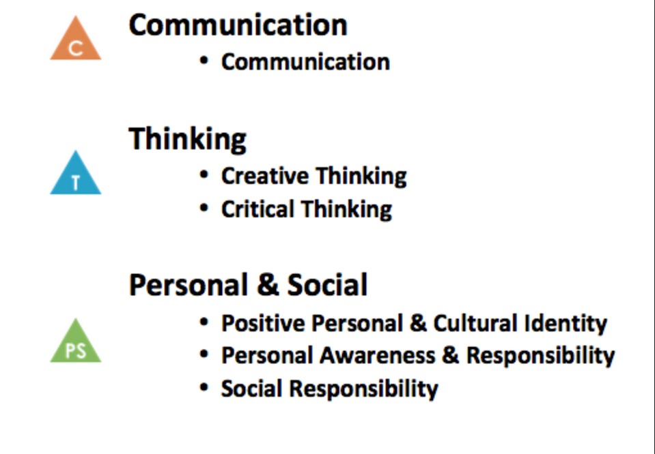
Possible guided questions (if needed):
- Tell me about overcoming difficulties.
- Identify your strengths within the competency. Give an example.
- How has learning in different subject areas helped you develop this competency?
- What growth has occurred for you in the particular competency?
- What does this competency mean to you? Why did you choose it?
- Is there a thread or theme that you can see in terms of your growth across the subjects?
- How does developing the competency help you find success out of school?
- How will you carry on or build upon the development of this competency in the future?
Suggested Timeline
Wed. April 5, 2017 (grade 8 only)
- Introduce core competencies and expectations (Handout One: Core Competency Overview)
- Ask students to decide which core competency they would like to prepare
- Hand student sign up sheets into Mr. Rockwell or Ms. Byrne
- Ask students to bring evidence, projects, or other evidence to work on next week

Wed. April 12, 2017 (grade 9s tutor leaders, please combine April 5th and April 12th lessons together due to presentation)
- Sign students up on computer as they want (individuals, pairs, group of 3) for their interview
- Review core competencies and hand out preparation sheets (Handout Two: I Can Statements)
- Ask students to work on their core competency evidence and I Can Statements by themselves
Wed. April 19, 2017
- Ask students to get into their pairs or groups of three, or work individually if they choose
- Talk about what a good interview might look like, sound like (Handout Three: Preparing for the Interview)
- Give students time to practice their interview with each other
Wed. April 26, 2017
- Last day to prepare; add evidence; complete mock interviews
- Hand out tutorial times and room numbers
- Last day of tutorial celebrations
Please let students know that they can talk with Ms. Carr (office), Mr. Rockwell (Room 31) or Ms. Byrne (Room 202) at any time if they have a question about the process or expectations.
LIZ: Supplies Required for Workshop
Stickies
Highlighters
Chart paper
Fidgets
Markers
Paper
Photocopies
Snacks

KENT: Grade 8/9 Handouts and Package

Google Docs Sign up for Week 2
Photocopies of Packages
Teacher List for Interviews

