Socials 8-11 Current Events

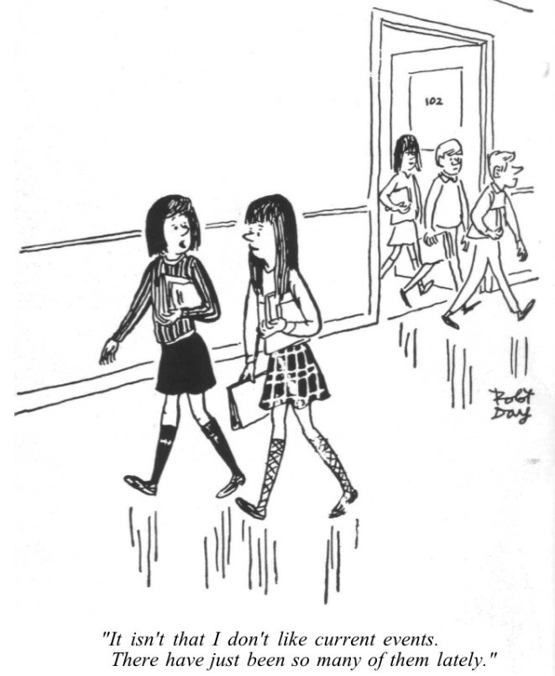
Preamble

Part of making history relevant is finding out what has happened in the past and making connections to contemporary issues. Many of the issues we deal with today need to be studied historically to truly understand their context and relevance. In keeping with this, current events must be an integral part of social studies.

Assignment

Every week you will be responsible to bring a current event to class and have a written summary about your article. You may not discuss your current event every week, but you must be prepared to speak to the class. The first five to fifteen minutes of every class will be dedicated to current events and a group discussion.

You must cut your current event out of a newspaper, print if off, or paste it into your write-up. Your topic may be local, provincial, national, or international in scope. However, sports and entertainment (brain candy) are NOT acceptable topics. The only exceptions to this are if there are deeper social consequences or historical relevance (eg. Anthems and kneeling) or if you or a classmate have been highlighted in the paper. Then we want to hear about it!

Once called upon, you will greet the audience and summarize the article, making sure that you are not reading off the sheet. Using the 5Ws will help for this. Thank the audience at the end and ask if there are any questions. Be prepared to answer questions from the teacher.

If you do not have access to the internet, printer, or a newspaper at home, not to worry. Come in before class starts and use the computer and printer at the back of the room.

Assessment Criteria:

After your current event presentation, take a rubric like this one from the extra sheets bin and self-assess. Put the completed self-assessment rubric in the blue folder.

CATEGORY | 4 | 3 | 2 | 1
Enthusiasm | Facial expressions and body language generate a strong interest and enthusiasm about the topic in others. | Facial expressions and body language sometimes generate a strong interest and enthusiasm about the topic in others. | Facial expressions and body language are used to try to generate enthusiasm, but seem somewhat faked. | Very little use of facial expressions or body language. Did not generate much interest in topic being presented.
Speaks Clearly | Speaks clearly and distinctly all (100-95%) the time, and mispronounces no words. | Speaks clearly and distinctly all (100-95%) the time, but mispronounces one word. | Speaks clearly and distinctly most of the time. Mispronounces no more than one word. | Often mumbles or cannot be understood OR mispronounces more than one word.
Posture and Eye Contact | Stands up straight, looks relaxed and confident. Establishes eye contact with everyone in the room during the presentation. | Stands up straight and establishes eye contact with everyone in the room during the presentation. | Sometimes stands up straight and establishes eye contact. | Slouches and/or does not look at people during the presentation.
Preparedness | Student is completely prepared and has obviously rehearsed. | Student seems pretty prepared but might have needed a couple more rehearsals. | The student is somewhat prepared, but it is clear that rehearsal was lacking. | Student does not seem at all prepared to present.
Content | Shows a full understanding of the topic. | Shows a good understanding of the topic. | Shows a good understanding of parts of the topic. | Does not seem to understand the topic very well.

Comments:

