Everyday Leadership
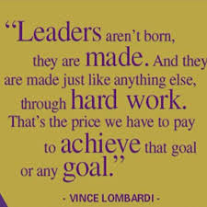
/20
Preamble

We have this concept that leadership is ‘official’ and comes with a job, an event, or a specific situation. In fact, leadership is a way of being: a building of authentic, caring relationships, an encouraging good communication, a creation of an inclusive space for all, an offering of time, and provision of reliability of self and vision with values. In other words, everything anyone is capable of becoming.
Assignment
It is time to take stock of yourself and figure out where you have strengths and where you might need to grow. You have 20 minutes silent writing time to complete this. Please be honest and know that I will share your responses with no one without permission, (unless health and safety is a concern, of course.)
Describe your three best qualities as a human being. Give an example of each one where you were ‘shining.’
1.______________________________________________________________________________________________________________________________________________________________ _____________________________________________________2.________________________________________________________________________________________________________________________________________________________________________________________________________________________________________________________________________3.________________________________________________________________________________________________________________________________________________________________________________________________________________________________________________________________________
What is/are your struggle(s) as a person? (in other words, where would you like to improve as a person?)
________________________________________________________________________________________________________________________________________________________________________________________________________________________________________________________________________________________________________________________________________________________________________________________________________________________________________

Take some time to think about a leader who has had an impact in your life. Why was that? What qualities did that leader offer?
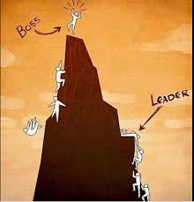

Explain a situation where you provided everyday leadership. Without fanfare, without reward. Just because it was ‘the right thing to do.’ ___________________________________________________________________________________________________________________________________________________________________________________________________________________________________________________________________________________________________________________________________________________________________________________________________________________________________________________________________________________________________________________________________________________________________________________________________________________________________________________________________________________________________________________________________________________________________________________________________________________________
Describe what a good leader… …sounds like…
…looks like……acts like…

