Get To Know You Info Sheet
(Please print neatly)

Full Name__________________________________________

Home Phone Number: ____________________________________

Parent/Guardian Cell: ____________________________________

Your Cell Number:_______________________

An email address you check regularly! _________________________________________________

Your school timetable (please let me know if it changes)
Period  Course  Teacher  Room | Period  Course  Teacher  Room
Period  Course  Teacher  Room | Period  Course  Teacher  Room
Period  Course  Teacher  Room | Period  Course  Teacher  Room
Period  Course  Teacher  Room | Period  Course  Teacher  Room

What do you hope to learn from this class?

What is your favourite subject to learn about and why?

Allergies I need to know about?

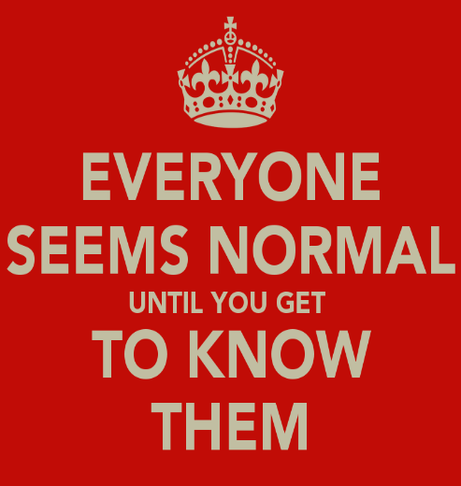
Intense Likes/Passions?

Intense Dislikes?

What do you want me to know about you?

What are your goals for this academic school year?

Any other tidbits I have missed? Or space to doodle if you’re done early!

