Have a Think about what makes you tick
/20
Preamble

There are many different personality types and we know that this is the ‘spice of life’ in relationships. While conflicting personalities can be challenging, this also provides so much richness, creativity, and hopefully many sparks of joy. Knowing your strengths means understanding what type of person you are, what makes you tick, and trying to be the ‘best you’ that you can be, instead of trying to be someone you are not.

Assignment

Today you have been given the time you need to have a think about your personality and read an article about introverts and extroverts. A simple explanation about these terms has to do with energy. Introverts often recharge by spending time alone. They lose energy from being around people for long periods of time, particularly large crowds or high energy people. While they often feel ‘guilt’ for disconnecting to read, being alone with music or taking walks, it is what they need to do, Extroverts, on the other hand, gain energy from other people. They will sometimes feel ‘bouncy’ or restless when not able to do this.

After reading the article, take the test below to try and figure out what kind of personality you are. Please keep in mind, however, that these tests are not prescriptive. In other words, they are very general and should not be utilized to peg people, creating a ‘self-fulfilling prophecy’ about oneself. They assess based on a moment in time, and results will likely change over time. As well, they are problematic when used by potential employers, as personality traits often have little to do with job strengths like reliability, work ethic, adaptability, or punctuality. Still, they offer some value, in general, to show trends in your thinking. At the very least, it will get you thinking about who you are as a person and what you need out of life.

Assessment /20

You will be assessed /4 for each section for the following: thoughtfulness, depth, understanding

BY JENN GRANNEMAN SCIENCE MARCH 4, 2015
Intoverts’ and extroverts’ brains really are different, according to science

You’re not imagining it. That extrovert who seems so different from you? It’s because his brain is different.
Introverts Are Sensitive to Dopamine
Why do extroverts like action, but introverts like calm?
It has to do with two powerful chemicals found in our brains — dopamine and acetylcholine, “jolt juices” that hugely impact our behavior.
Dopamine gives us immediate, intense zaps of happiness when we act quickly, take risks, and seek novelty. Acetylcholine, on the other hand, also rewards us, but its effects are more subtle — it makes us feel relaxed, alert, and content.
Extroverts are less sensitive to dopamine, so they need more of it to feel happy. The more they talk, move, and seek new faces, the more they feel dopamine’s pleasant effects.
But we introverts are sensitive to dopamine, so too much of it makes us feel overstimulated and anxious, writes Dr. Marti Olsen Laney in her book, The Introvert Advantage: How to Thrive in an Extrovert World.
However, when we read, concentrate, or use our minds in any way, we feel good because our brains release acetylcholine. Extroverts, on the other hand, hardly register acetylcholine’s gentle happiness bump.
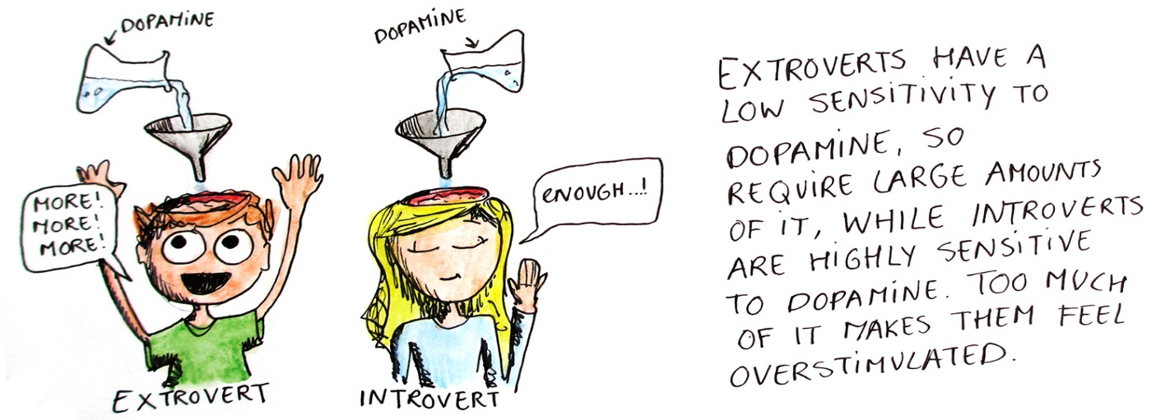
From “The introvert brain explained”

Introverts Prefer a Different Side of Their Nervous System
Everyone’s nervous system has two sides — the sympathetic side, which triggers the “fight, fright, or flight” response, and the parasympathetic side, which is responsible for “rest and digest” mode.
Think of the sympathetic side as hitting the gas pedal and the parasympathetic side as slamming on the brakes.
When your sympathetic system is activated, your body gears up for action. Adrenaline is released, glucose energizes muscles, and oxygen increases. Areas of your brain that control thinking are turned off, although dopamine increases alertness in the back of your brain.
But when you use the parasympathetic side, your muscles relax, energy is stored, and food is metabolized. Acetylcholine increases blood flow and alertness in the front of your brain.
Of course, extroverts and introverts use both sides at different times. But which side do we introverts prefer? You’ve probably already guessed: according to Dr. Laney, the parasympathetic side, which slows us down and calms us.

Introverts Use the Long Acetylcholine Pathway
Ever wonder why, as an introvert, you overthink?
It has to do with how we process stimuli in a different way than extroverts do.
When information from the outside world — like someone’s voice or images on a computer screen — enters an extrovert’s brain, it travels a shorter pathway, passing through areas of the brain where taste, touch, sight, and sound are processed.
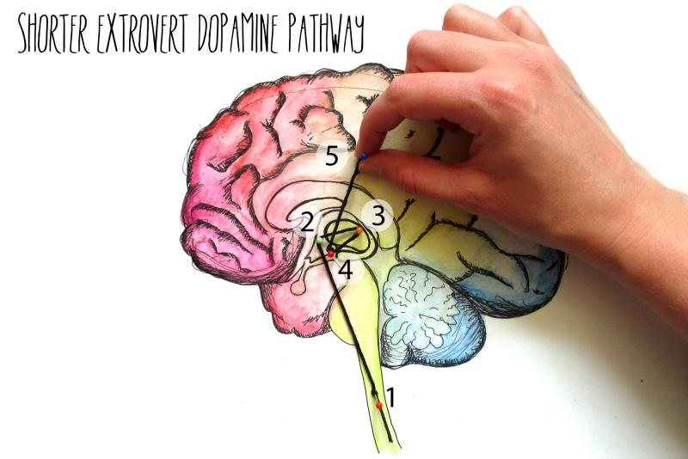
From “The introvert brain explained”
But for us introverts, the pathway is much longer. Stimulation travels through many areas of the brain, including:
- The right front insular, which is an area associated with empathy, self-reflection, and emotional meaning. This is also the area of the brain that notices any errors.
- Broca’s area, which plans speech and activates self-talk.
- The right and left front lobes, which select, plan, and choose ideas or actions. These areas also develop expectations and evaluate outcomes.
- The left hippocampus, which stamps things as “personal” and stores long-term memories.
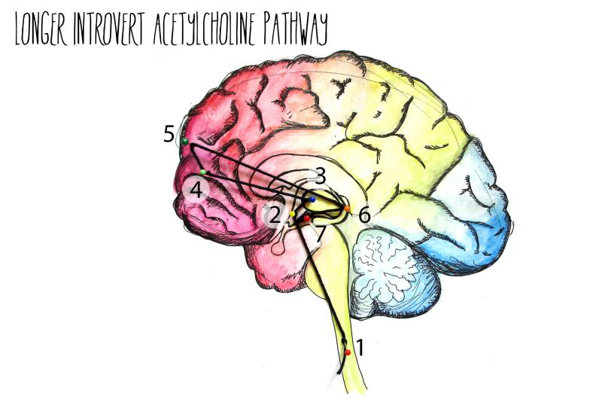
From “The introvert brain explained”
This means we process information more thoroughly and deeply. No wonder it sometimes takes us longer to speak, react, or make decisions!

Introverts Have More Gray Matter
A study published in the Journal of Neuroscience found that introverts had larger, thicker gray matter in their prefrontal cortex, which is the area of the brain that is associated with abstract thought and decision-making. Extroverts had thinner gray matter in that same area. This suggests that we devote more neural resources to abstract thought, while extroverts tend to live in the moment.
What This Means
It means that as an introvert, you were probably born this way — although, of course, your background and experiences play a role in shaping you, too.
It doesn’t mean that you’ll never enjoy a party or seek new experiences, or that an extrovert will never sit still and read a book — we still get to choose what we do.
And of course, “introversion and extroversion are not black and white. No one is completely one way or another — we all must function at times on either side of the continuum,” Dr. Laney reminds us in her book, The Hidden Gifts of the Introverted Child.
That extrovert? Give him a break. It’s his brain.
Image credit: Michal Hustaty
https://introvertdear.com/news/introverts-and-extroverts-brains-really-are-different-according-to-science/
https://www.quietrev.com/why-introverts-and-extroverts-are-different-the-science/

Assignment

- Read the article
- In Room 207, log in and go to the following site: http://www.humanmetrics.com/cgi-win/jtypes2.asp.
- Complete the online questionnaire.
- Go to the ‘read full description’ box and read it.
- Print it out double-sided and staple it to the back of this assignment.
- Answer the following with thought and depth:

- How many personality types are there altogether and what does that mean for you as a Leader?

- Explain the four ‘overall’ personality types. (extraversion/introversion, sensing/intuition, thinking/feeling, judging/perceiving)

- What personality type are you? What are the 4 main aspects of this personality type? Describe.

- Do you agree with this assessment of your personality? Professions that it suggests for you? Explain.

- Application of knowledge: What does this knowledge about personalities mean for you as a Leader? How can you apply this to Leadership and/or your everyday life?

Other comments/learning/tidbits:

