Leadership Community Opportunity
WHO: Leaders and Mentors
WHAT: Red Cross Humanitarians in Training (RCSM)
WHERE: University of British Columbia
WHY: Conference and workshops on leadership and humanitarian issues
WHEN: SATURDAY, NOV. 16, 2019 from 9-5:30pm

Please note: It is VERY important that you show up once committed to this, arrive early and do your best to represent well!
Please print:
I _________________________________ (parent/guardian) give permission for my child ________________________________ (print name) to participate in this community activity. For out of school time activities, I understand that students may be going to the event without school supervision, there may not be school supervision at the event and they may be returning home on their own.

Please note that food is provided, but if your child has allergies/aversions, s/he should pack a lunch!

Parent/Guardian Signature:_________________________________________
Parent/Guardian Phone Number:______________________________________
Student Cell Number:______________________________________________

If you have any questions, please contact Elizabeth Byrne (Mentorship/Leadership teacher) at Elizabeth.byrne@burnabyschools.ca or call the school at the number above.

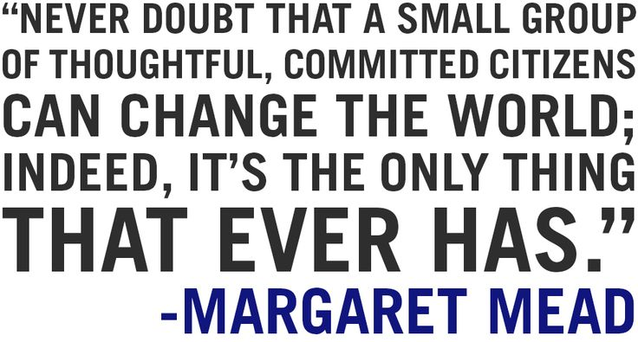
Two steps must be taken for student delegates to register:
- Please REPLY to this email with the full names of the three students that you are interested in sending as delegates.
- Please direct students selected by yourself and/or your staff to REGISTER themselves using this application form: https://forms.gle/qqaTjj2Zy2ncdPoD9

For more information and photos from past events, please refer to our website: https://www.humanitariansintraining.com/

