Senior Leadership
Community and ‘Other’
/20

“Power exists as long as the group stays together against the “others”… Exercising power over other people affects them, through action or inaction…whether or not those who exercise power are aware of the success or consequences of their practices and whether or not the other party is aware of the power being exercised over him or her.” – Professor Philomena Essed, sociologist

Preamble

Now that you have a solid understanding of the idea and importance of community and inclusion, it is time to have a think about two main ideas that are crucial for true cohesion for community and inclusion. The idea of ‘identity’ and sense of ‘other’ are key components to building community that is inclusive to all. These are social constructs that weave into the very fabric of how we see ourselves, and how we see ourselves in relation to others.

The idea of identity is core to our personal narrative and who we are as humans; it is our essence. With whom do we identify? How do we see ourselves? Do we identify with others based on culture, race, language, ethnicity, age, interests?

The idea of ‘other’ is equally important in community. Every society has a dominant ‘norm.’ Where do we fit within it? Do we see ourselves as part of mainstream society, or do we see society as sometimes not supportive, even working against us? Gender, race, sexuality, and religion are common areas where we view ourselves as ‘other’ and seeing ourselves as separate from mainstream society. Unless we incorporate voices of dissent, ensure there is a spot at the table for all, and value all contributions in strength-based leadership, there will always be divisions in the communities in which we exist.

Assignment

You have one class to watch the video at the following site, read the articles provided, and answer the questions. These are major ideas and deep-thinking questions, so be prepared for your brain to hurt and to feel a bit ‘Byrne-poked’ by the end of class. As always, share only what you are comfortable with Byrne reading, and know no one will see it unless health or safety is in question.

Assessment

As always, you will be assessed for deep thought, willingness to engage in heady materials, honesty, and accuracy.

Watch the following video (Embracing Otherness, Embracing Myself) and write down the key points. https://www.ted.com/talks/thandie_newton_embracing_otherness_embracing_myself/transcript?language=en

What is your personal identity? With whom/what do you identify yourself?

Read the following article on race and ethnicity. What is a social construct? What role does it play in society?

Discuss the role of race/ethnicity/language/culture in identity.

What is the difference between race and ethnicity?
Dalton Conley
While race and ethnicity share an ideology of common ancestry, they differ in several ways. First of all, race is primarily unitary. You can only have one race, while you can claim multiple ethnic affiliations. You can identify ethnically as Irish and Polish, but you have to be essentially either black or white. The fundamental difference is that race is socially imposed and hierarchical. There is an inequality built into the system. Furthermore, you have no control over your race; it's how you're perceived by others. For example, I have a friend who was born in Korea to Korean parents, but as an infant, she was adopted by an Italian family in Italy. Ethnically, she feels Italian: she eats Italian food, she speaks Italian, she knows Italian history and culture. She knows nothing about Korean history and culture. But when she comes to the United States, she's treated racially as Asian.
John Cheng
I think most people associate race with biology and ethnicity with culture. It's important to stress the culture and language part of it. Ethnicity isn't just a question of affiliation; it's also a question of choice. It's also a question of group membership. And it's usually associated with a geographic region. It's also often confused or conflated with nationality, but that's not the same thing. Today people identify with ethnicity positively because they see themselves as being part of that group. People can't just simply say, "Well, I want to become a member of that race." You either are or are not a member of that race. Whereas, if you wanted to look at ethnicity based on culture, you could learn a language, you can learn customs - there are things that you can learn so that you could belong to that group.
I think the most powerful argument about the differentiation between race and ethnicity is that race becomes institutionalized in a way that has profound social consequences on the members of different groups.
David Freund
I agree. The most important differences, at least in much of U.S. history, lie in the ways that dominant powerful institutions treat race versus ethnicity. So while one could argue that both ethnicity and race are socially constructed, their influence in terms of power and inequality is in the way that racial identities have been constructed historically. One could argue that they're both illusory and imagined. But racial categories have had a much more concrete impact on peoples' lives, because they've been used to discriminate and to distribute resources unequally and set up different standards for protection under law. Both public policy and private institutional and communal actions have created inequalities based on race. To be sure, groups defined as "ethnically" different have been discriminated against in the U.S. too, but not in ways that had nearly as dramatic an impact. Indeed, those "ethnic" groups that suffered from severe discrimination were usually labeled, at the time, as "racial" groups as well. Consider the history of discrimination against the Irish, Italians, and Jews, for example.
People commonly make these distinctions between race and ethnicity as being biological, or cultural, or based on national origins and things like that. But it's really important to remember two things. First, both ethnic and racial identities have changed a lot throughout history. And second, there's very little evidence that people actually see great distinctions between race and ethnicity culturally, politically, and in daily life. In fact, there is a history of racial self-identification in this country that is very similar to that of ethnic self-identification.
Italians, Jews, and Slavs were considered non-white in popular political discourse of the late 19th and early 20th century, and this discourse grew very influential in the anti-immigration movement, leading eventually, in the 1920s, to severe restrictions against entry of supposedly "non-white" groups to this country. This popular pseudo-science made it into the pages of the Saturday Evening Post and other magazines, supporting immigration restrictions against the "Alpine" and the "Mediterranean" races, described as the long-skulled, slow, peasant stock people of Central Europe, etc. Most of these immigrants were not running around in the 19th and early 20th century proudly announcing that they're Italian Americans or Slavic Americans because at the time, it was often very dangerous and at least a disadvantage to be identified that way. I think we call these groups an ethnicity and not a race now, because those categories have actually changed. This is due in large part to a series of policy decisions that gave some groups certain advantages in the 1930s, '40s, and '50s, allowing them to be part of an ever-expanding "white" race. The political context and the power context changes. Ethnicity, like race, takes on different meanings.
Sumi Cho
In the law, I think there's a failure to seriously grasp the significance of the impact of racial exclusion and white supremacy in this society. There are many who don't believe that racial divisions are much different from ethnicity-based divisions; i.e., what African Americans have faced in this country is little different from what Irish Americans or Italian Americans have faced.
In the legal sphere, you get these court decisions that endorse affirmative action programs that promote forward-looking rationales, like diversity for a university, let's say, but don't allow programs that promote backward-looking rationales, such as remedying general societal discrimination, unless you have a specific documented case of past discrimination. So you end up with this ungrounded, untethered notion of general diversity which has nothing to do with the real impact of race in society. There's an asymmetry that's important to keep in mind when we're talking about race versus ethnicity. Yet politicians deliberately further this non-distinction between race and ethnicity, especially conservative politicians who want to downplay the significance of racial discrimination in this country.
https://www.pbs.org/race/000_About/002_04-experts-03-02.htm

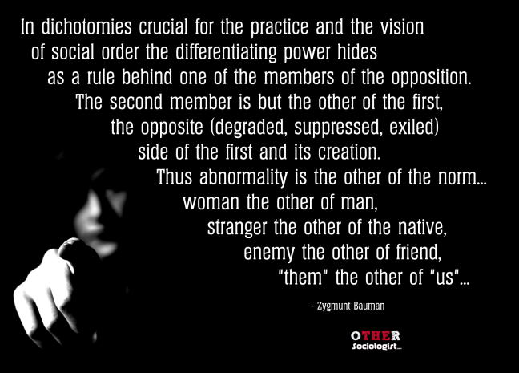

What is Otherness?

This page provides a sociological definition of otherness and how it works in societies. I will also include examples and resources for people interested in learning more about otherness. I will add to this page over time.

Defining Otherness
The idea of ‘otherness’ is central to sociological analyses of how majority and minority identities are constructed. This is because the representation of different groups within any given society is controlled by groups that have greater political power. In order to understand the notion of The Other, sociologists first seek to put a critical spotlight on the ways in which social identities are constructed. Identities are often thought as being natural or innate – something that we are born with – but sociologists highlight that this taken-for-granted view is not true.

Rather than talking about the individual characteristics or personalities of different individuals, which is generally the focus for psychology, sociologists focus on social identities. Social identities reflect the way individuals and groups internalise established social categories within their societies, such as their cultural (or ethnic) identities, gender identities, class identities, and so on. These social categories shape our ideas about who we think we are, how we want to be seen by others, and the groups to which we belong.

George Herbert Mead’s classic text, Mind Self and Society, established that social identities are created through our ongoing social interaction with other people and our subsequent self-reflection about who we think we are according to these social exchanges. Mead’s work shows that identities are produced through agreement, disagreement, and negotiation with other people. We adjust our behaviour and our self-image based upon our interactions and our self-reflection about these interactions (this is also known as the looking glass self).

Ideas of similarity and difference are central to the way in which we achieve a sense of identity and social belonging. Identities have some element of exclusivity. Just as when we formally join a club or an organisation, social membership depends upon fulfilling a set of criteria. It just so happens that such criteria are socially-constructed (that is, created by societies and social groups). As such ‘we’ cannot belong to any group unless ‘they’ (other people) do not belong to ‘our’ group. Sociologists set out to study how societies manage collective ideas about who gets to belong to ‘our group’ and which types of people are seen as different – the outsiders of society.

Zygmunt Bauman writes that the notion of otherness is central to the way in which societies establish identity categories. He argues that identities are set up as dichotomies:

Gender
The concept of The Other highlights how many societies create a sense of belonging, identity and social status by constructing social categories as binary opposites. This is clear in the social construction of gender in Western societies, or how socialisation shapes our ideas about what it means to be a “man” or a “woman.” There is an inherently unequal relationship between these two categories. Note that these two identities are set up as opposites, without acknowledging alternative gender expressions. In the early 1950s, Simone de Beauvoir argued that
Otherness is a fundamental category of human thought. Thus it is that no group ever sets itself up as the One without at once setting up the Other over against itself. de Beauvoir argued that woman is set up as the Other of man. Masculinity is therefore socially constructed as the universal norm by which social ideas about humanity are defined, discussed and legislated against.

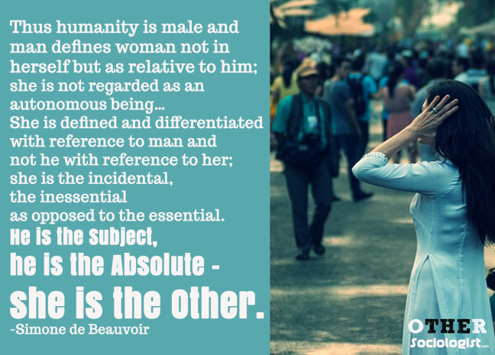

Thus humanity is male and man defines woman not in herself but as relative to him; she is not regarded as an autonomous being… She is defined and differentiated with reference to man and not he with reference to her; she is the incidental, the inessential as opposed to the essential. He is the Subject, he is the Absolute – she is the Other.’ – Simone de Beauvoir, The Second Sex

Power
Dichotomies of otherness are set up as being natural and so often times in everyday life they are taken for granted and presumed to be natural. But social identities are not natural – they represent an established social order – a hierarchy where certain groups are established as being superior to other groups. Individuals have the choice (or agency) to create their identities according to their own beliefs about the world. Yet the negotiation of identity equally depends upon the negotiation of power relationships. As Andrew Okolie puts it:
Social identities are relational; groups typically define themselves in relation to others. This is because identity has little meaning without the “other”. So, by defining itself a group defines others. Identity is rarely claimed or assigned for its own sake. These definitions of self and others have purposes and consequences. They are tied to rewards and punishment, which may be material or symbolic. There is usually an expectation of gain or loss as a consequence of identity claims. This is why identities are contested. Power is implicated here, and because groups do not have equal powers to define both self and the other, the consequences reflect these power differentials. Often notions of superiority and inferiority are embedded in particular identities (2003: 2).
Social institutions such as the law, the media, education, religion and so on hold the balance of power through their representation of what is accepted as “normal” and what is considered Other. British sociologist Stuart Hall argues that visual representations of otherness hold special cultural authority. In Western countries with a colonial history, like the UK, Australia and the USA, whether difference is portrayed positively or negatively is judged against the dominant group – namely White, middle-to-upper class, heterosexual Christians, with cis-men being the default to which Others are judged against.

The notion of otherness is used by sociologists to highlight how social identities are contested. We also use this concept to break down the ideologies and resources that groups use to maintain their social identities. Sociologists are therefore interested in the ways in which notions of otherness are managed in society. For example, we study how some groups become stigmatised as outsiders, and how such ideas change over time. As Dutch-American sociologist Philomena Essed argues, the power of othering includes opting out of “seeing” or responding to racism.

https://othersociologist.com/otherness-resources/

What have you learned about community/identity/inclusion/otherness today? What are your takeaways?

