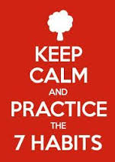
Intro Leadership
Getting Personal (PBA)
/40
Preamble

Now that we have ‘settled’ into the rhythm of the class and learning expectations, it is time to ‘stretch and grow’ a bit, reflect upon your state of mind, and think about positive habits you have developed, as well as negative habits you might want to break in a hurry. Are you taking risks to improve yourself? Are you existing or thriving? Time to take stock!

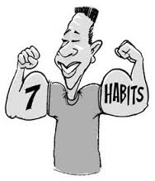
Assignment

This is an individual assignment and you have this class to complete it. Please hand it in before you leave the classroom. Remember, I will be assessing these, so please only write what you feel you can share with me.

- Read pp. 31-46. Remember to read the inserts in boxes and the cartoons as well.
- Answer the following below:

- Personal Bank Account: What is this concept?
_______________________________________________________________________________________________________________________________________________________________

List areas where you think you demonstrate…
Poor PBA | Healthy PBA

- KEEP PROMISES TO YOURSELF
Think of a time where you broke a promise to yourself and explain why you did so.

Now explain a time where you kept a promise to yourself and how you felt about it.

- SMALL ACTS OF KINDNESS
Explain how erring on the side of kindness helps YOU in the long run.

- BE GENTLE WITH YOURSELF

How are you kind to yourself? In which ways are you too harsh on yourself? How can you change this?

- BE HONEST
Being honest take a deep breath and 5 seconds of courage sometimes. When have you been in a situation where you have been honest, even though it ‘cost you’ to do so? Who have you been dishonest with and why? (Remember…’omissions’ and omitting the ‘squishy’ parts of stories are another way that we are dishonest.)

Sometimes, is being ‘right’ more important to you than being truthful? Why is that?

- RENEW YOURSELF
You are not a machine. How do you take care of yourself? Where do you need to improve in this regard?

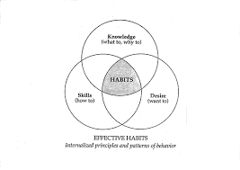
- TAP INTO YOUR TALENTS
Where do your talents lie so far? What have you always wanted to try but haven’t yet? What’s stopping you?

Summary

INTEGRITY
Being an authentic leader means that you ‘are who you are’ no matter who is in front of you and what the situation is. Time to take stock and be honest. How are you being a leader in your other classes? In the school? In the community? In your family?
______________________________________________________________________________________________________________________________________________________________________________________________________________________________________________________________________________________________________________________________________________________________________________________________________________________________________________________________________________________________________________________________________________________________________________________________________________________________________________________________________________________________________________________________________________________________________

