Leadership Conflict Resolution Assignment
/25
Preamble

Part of learning to mitigate conflict in your life is understanding what you can control and what you need to ‘let go’ in order to move forward. Today in Intro Leadership you have some time to think about this and you will be given some questions, hopefully to ‘poke’ your thinking a little bit.
Assignment
Take a 7 Habits of Highly Effective Teens course book and complete the following:
- Find your own quiet spot in the room
- Read pp. 48-72
- Using the space below, complete your own ‘Circle of No Control’ /6
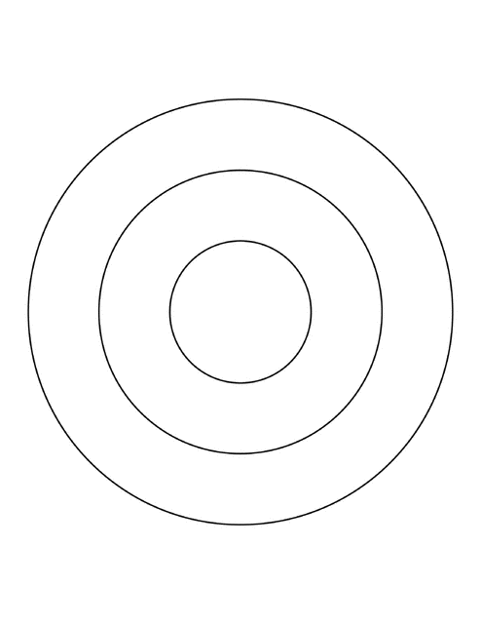
4, Identify something in your circle of no control that you are always worrying about. How are you going to drop it? /2
_____________________________________________________________________________________________________________________________________________________________________________________________________________________
5. What is your most unhealthy habit? /2
______________________________________________________________________________________________________________________________________________

6. What are you going to do to get rid of your most unhealthy habit? /2
_____________________________________________________________________________________________________________________________________________________________________________________________________________________
7. Page 66 discusses ‘tools in the tool belt’ and what that means for our mindset. Take a minute and honestly assess your tools. How strong are these ‘tools’ in your kit? Be specific. /4
Self-Awareness:

Conscience:

Imagination:

Willpower:

8. What are your tools/strengths not mentioned above? Take stock of them here. /4

9. Pick a quote that really resonates with you. Write about why it ‘spoke to you’ and discuss your thoughts about it.

For good ideas and true innovation, you need human interaction, conflict, argument, debate. Margaret Heffernan
When times are tough and people are frustrated and angry and hurting and uncertain, the politics of constant conflict may be good, but what is good politics does not necessarily work in the real world. What works in the real world is cooperation. William J. Clinton
To avoid criticism say nothing, do nothing, be nothing. – Aristotle
I don't like the word 'balance.' To me, that somehow conjures up conflict between work and family... as long as we think of these things as conflicting, we will never have happiness. True happiness comes from integration... of work, family, self, community. Padmasree Warrior
Most misunderstandings in the world could be avoided if people would simply take the time to ask, “What else could this mean?” – Sharon Adler
When you don't manage your life well, you become angry and frustrated as things don't go as intended, and our bad mood is a sign showing we were not able to resolve the conflict. Jorge Bucay
Difficulties are meant to rouse, not discourage. The human spirit is to grow strong by conflict. William Ellery Channing
The more we run from conflict, / The more it masters us; / The more we try to avoid it, / The more it controls us; / The less we fear conflict, / The less it confuses us; / The less we deny our differences, / The less they divide us. – David Augsburger
Conflict grows out of ignorance and suspicion. Gordon B. Hinckley
Peace is not absence of conflict, it is the ability to handle conflict by peaceful means. Ronald Reagan
The hottest place in Hell is reserved for those who remain neutral in times of great moral conflict. Martin Luther King, Jr.
Speak when you are angry and you will make the best speech you will ever regret. – Ambrose Bierce
If you want to bring an end to long-standing conflict, you have to be prepared to compromise. Aung San Suu Kyi
In elementary school, we should teach nonviolent conflict resolution and healthy communication skills, which will help children cope with issues like rejection and sexuality later in life. Jane Velez-Mitchell
Transformation comes more from pursuing profound questions than seeking practical answers. – Peter Block
There are two ways of meeting difficulties: You alter the difficulties or you alter yourself meeting them. – Phyllis Bottome
If war is the violent resolution of conflict, then peace is not the absence of conflict, but rather, the ability to resolve conflict without violence. – C.T. Lawrence Butler
Don’t let yesterday use up too much of today. – Cherokee proverb
A stiff apology is a second insult…The injured party does not want to be compensated because he has been wronged; he wants to be healed because he has been hurt. – Gilbert Chesterton
Never apologize for showing feeling. When you do so, you apologize for the truth. – Benjamin Disraeli
When we change the way we look at things, the things we look at change. – Wayne Dyer
Write your quote here and write a response explaining, with thought and depth, why you ‘connect’ with this quote. /5
____________________________________________________________________________________________________________________________________________________________________________________________________________________________________________________________________________________________________________________________________________________________________________________________________________________________________________________________________________________________________________________________________________________________________________________________________________________________________________________________________________________________________________________________________________________________________________________________________________________________________________________________________________________________________________________________________________________________________________________________________________________________________________________________________________________________________

