Mentorship 11/12
2018/2019

The delicate balance of mentoring someone is not creating them in your own image, but giving them the opportunity to create themselves.
Steven Spielberg

Preamble

Mentorship is a process whereby someone with expertise/experience gives her/his time and knowledge to help someone else succeed. Research tells us that mentoring works for children and teenagers. Students with mentors develop more positive attitudes towards school. By establishing a positive long-term relationship with a caring teen, younger people can increase their confidence, their self-esteem and their sense of hope. (https://alis.alberta.ca/pdf/cshop/aaet/mentorhandbook.pdf)
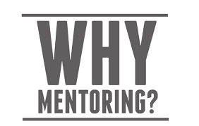
However, mentoring also benefits the mentor. Besides the obvious sense of connection and sense of satisfaction that comes with helping others, mentors also have the opportunity to build their own skills, knowledge and confidence by providing mentorship.

What Is Expected of You?

To be successful in this course, you must ensure the following:

- Reliability: be in mentorship class (and tutorial class), on time, learning what you need to learn to be able to help your junior students.
- Good communication: with your teacher(s), your classmates and your mentors
- Authenticity: make a genuine connection with your students and be positive in your relationship with them as a mentor. For it to be a meaningful and trusting relationship, you need to care about what they learn and how they are doing.
- Open-mindedness: You will be asked to share your existing knowledge and skills; however, you will also be poked and challenged to learn more. We ask that you offer a willingness to learn, take risks and ‘stretch and grow in this course this year. This includes all in class and out of class activities.
- Kindness: the art of being who you are no matter who is in front of you; kindness takes strength.

Course Structure

Mentors are expected attend the following:
- all mentorship classes (unless ‘life’ intervenes - good communication with teacher is vital)
- specific out of school events (such as Gr. 8 Retreat) where possible
- all tutorial classes (junior students will be relying on you!)

Course Topics

This is not an extensive list, but this class will explore the following and more:

- How to plan /run an event (eg. Gr. 8 retreat, Parent Walk Around, Viking for a Day)
- How to plan a class (eg. Tutorial days)
- What is mentorship versus leadership?
- What are my values/strengths?
- Goal-setting
- How do people learn?
- What is effective communication?
- Study Skills
- High Five training
- Red Cross training
- Anti-bullying training
- How can I connect with my community?
- 7 Habits of Highly Effective Teens

Assessment
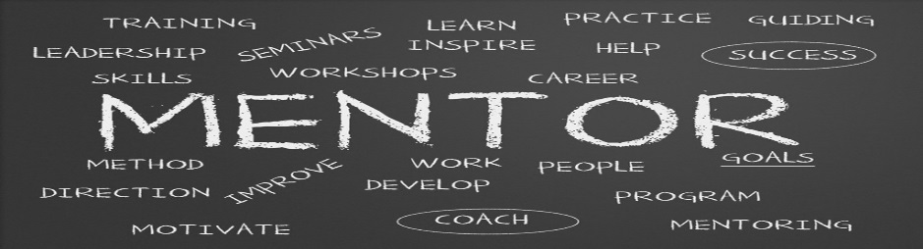
This core purpose of this course is to provide a venue for senior students to connect positively with junior students and offer their time, expertise and caring, in order to effect positive change. In keeping with this, there will be self, peer and teacher formative and summative assessments over the course of the year based on your personal growth, your involvement, your assignments.

Assignments: 50% (portfolio, performance tasks, journals, reflections, etc.)
Participation: 50% (tutorials, events, class engagement, service/volunteer
contributions, etc.)
.

