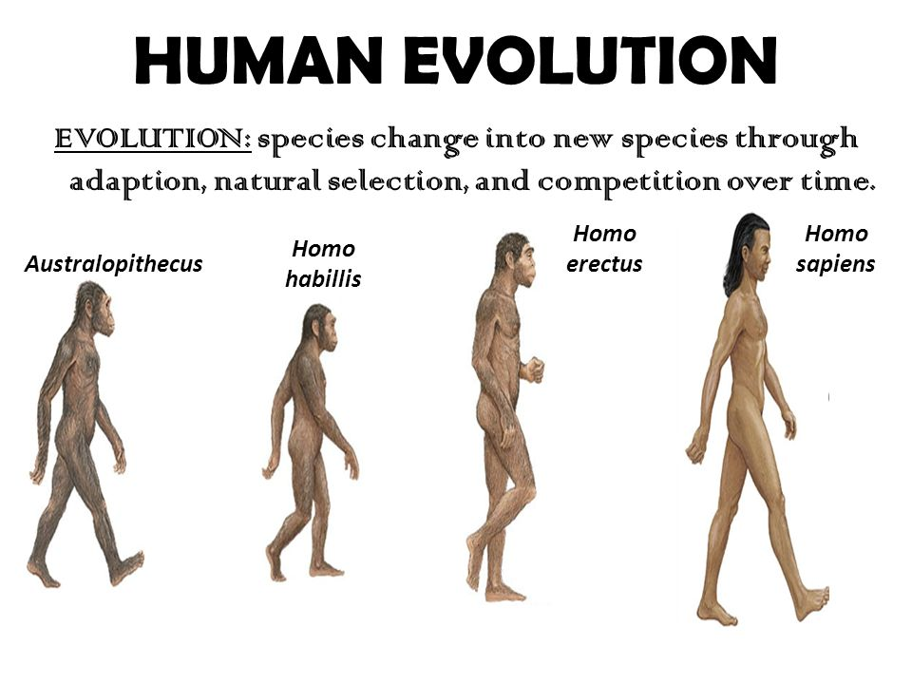

In the space above, write down the distinguishing features between these four species, including general dates when they walked the earth.

