Leadership Community Opportunity
WHO: Rotary Boots for Kids Fundraiser Initiative
WHAT: Rotary Festival of Lights CHRISTAMAS TREE DECORATION
WHERE: Brentwood Mall (outside London Drugs)
WHY: Senior Leadership Community Class Initiative (10 students MAX)
WHEN: TUESDAY, Nov. 20th, 2018 from 6-8pm
Please note: It is VERY important that you show up once committed to this, arrive early and do your best to represent well!

Please print:

I _________________________________ (parent/guardian) give permission for my child ________________________________ (print name) to participate in this community activity. For out of school time activities, I understand that students may be going to the event without school supervision, there may not be school supervision at the event and they may be returning home on their own.

Parent/Guardian Signature:_________________________________________
Parent/Guardian Phone Number:______________________________________
Student Cell Number:______________________________________________

If you have any questions, please contact Elizabeth Byrne (Mentorship/Leadership teacher) at Elizabeth.byrne@burnabyschools.ca or call the school at the number above.

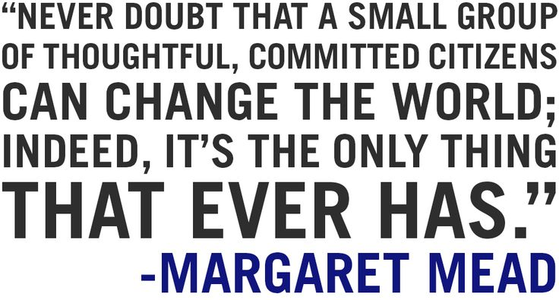

Please Note:
- For this activity you must sign in and out with Nasim Jiwa <nasim_jiwa@yahoo.com> from Rotary if Ms. Byrne is unable to attend.
- There are a limited number of spots available for this community event and will be allotted on a ‘first form back, first spot secured’ basis!

