Senior Leadership Field Experience Opportunity

WHO: Senior Leadership Students Only
WHAT: Organizing Hampers for Families in Community
WHERE: Safeway at Kensington
WHY: Because We All Have Inner Elves
WHEN: Mon. Dec. 2th and maybe Wed. Dec. 4, 2019
Block One: 9-10am Block Two: 10:30-11:30am
Please note: It is VERY important that you show up once committed to this, arrive early and do your best to represent well! Dress appropriately for a community event. Santa hats/reindeer antlers or equivalent are mandatory.

Please print:

I _________________________________ (parent/guardian) give permission for my child ________________________________ (print name) to participate in this community activity. For out of school time activities, I understand that students may be going to the event without school supervision, there may not be school supervision at the event and they may be returning home on their own.

Parent/Guardian Signature:_________________________________________
Parent/Guardian Phone Number:______________________________________
Student Cell Number:______________________________________________

If you have any questions, please contact Elizabeth Byrne (Mentorship/Leadership teacher) at Elizabeth.byrne@burnabyschools.ca or call the school at the number above.

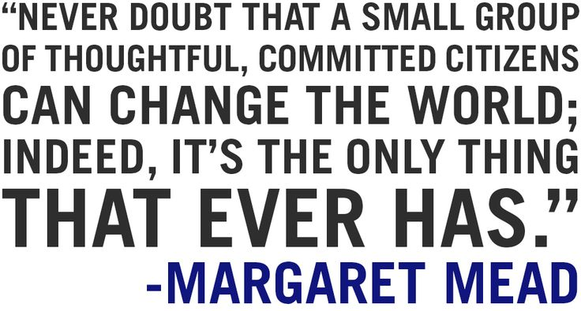

Return this to Ms. Byrne in Room 202 by THURSDAY, NOV. 28, 2019. No lates.

