Mentorship/Leadership School Community Opportunity
WHO: Viking for a Day!
WHAT: Help With Set-Up , Activities, Clean Up
WHERE: BNSS

WHY: Community Opportunity: Mentorship and Some Leadership Students
WHEN: WEDNESDAY, June 5th all day (Day One)

Please note: It is VERY important that you show up once committed to this, arrive early and do your best to represent well!

Please print:
I _________________________________ (parent/guardian) give permission for my child ________________________________ (print name) to participate in this volunteer activity. For out of school time activities, I understand that students may be going to the event without school supervision, there may not be school supervision at the event and they may be returning home on their own.

Parent/Guardian Signature:_________________________________________
Parent/Guardian Phone Number:______________________________________
Student Cell Number:______________________________________________
Student Email:___________________________________________________
Any food allergies or sensitivities? If no, please state no:___________________

If you have any questions, please contact Elizabeth Byrne (Mentorship/Leadership teacher) at Elizabeth.byrne@sd41.bc.ca or call the school at the number above.

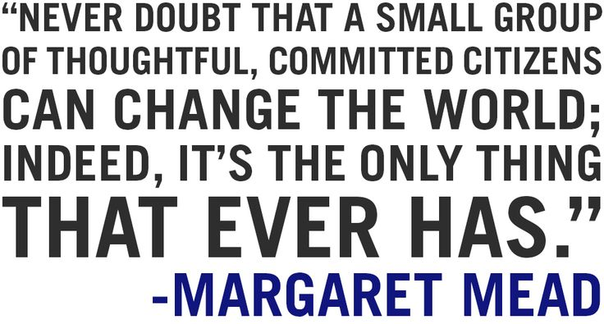

Return this to Ms. Byrne in Room 202 by FRIDAY, MAY 31st, 2019.

Mentorship/Leadership School Community Opportunity

Please have the appropriate teachers sign this form and discuss with them what you will be missing for the day/part of day. Hand in your work promptly.

Mentors, as this is making connections with grade 7 students, and that is part of the course mandate, it is very important that you attend Viking for a Day.

If you have any questions/comments/concerns, please contact Elizabeth Byrne at Elizabeth.byrne@burnabyschools.ca or pop into Room 202 to chat.

Period 1  Subject: | Teacher Signature:  Comments:
Period 2  Subject: | Teacher Signature:  Comments:
Period 3  Subject: | Teacher Signature:  Comments:
Period 4  Subject: | Teacher Signature:  Comments:

